**GAME DESIGN DOCUMENT**

Need for Speed

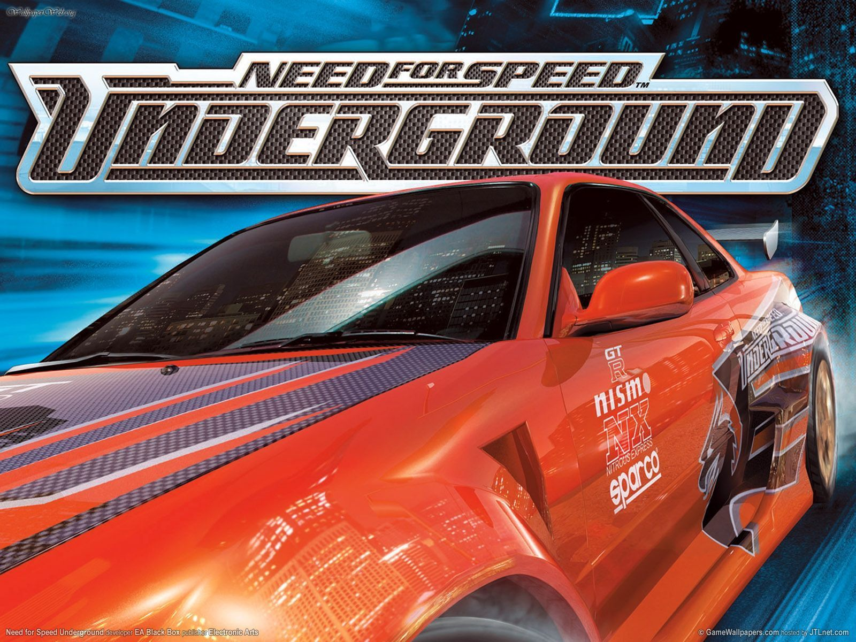

Underground

**Last Updated:**

26/03/2020

**Prepared By:**

Marko Gašparec

**TABLE OF CONTENTS**

Game Analysis 3

Mission Statement 3

Genre 3

Platforms 3

Target Audience 3

Storyline & Characters 4

Gameplay 8

Overview of Gameplay 8

Player Experience 9

Gameplay Guidelines 10

Game Objectives & Rewards 10

Gameplay Mechanics 18

Level Design 21

Control Scheme 31

Game Aesthetics & User Interface 32

Schedule & Tasks 43

# Game Analysis

Underground rebooted the franchise, ignoring the previous Need for Speed games which featured sports cars and exotics. It was the first game in the series to offer a career mode featuring a storyline, and a garage mode that allowed players to fully customize their cars with a large variety of brand-name performance and visual upgrades. All races take place in a generic city at night called Olympic City, though the city bears some resemblance to [New York City](https://en.wikipedia.org/wiki/New_York_City), [San Francisco](https://en.wikipedia.org/wiki/San_Francisco) and [Los Angeles](https://en.wikipedia.org/wiki/Los_Angeles). Rather than exotic cars, Underground featured vehicles associated with the [import scene](https://en.wikipedia.org/wiki/Import_scene).

# Mission Statement

Ready to own the streets? Get behind the wheel of iconic cars and floor it through Olympic City, a sprawling urban playground. Explore overlapping stories as you build your reputation – and your dream car – and become the ultimate racing icon.

# Genre

Racing, Action, Crime, Sport

# Platforms

[Microsoft Windows](https://en.wikipedia.org/wiki/Microsoft_Windows), [PlayStation 2](https://en.wikipedia.org/wiki/PlayStation_2), [GameCube](https://en.wikipedia.org/wiki/GameCube), [Xbox](https://en.wikipedia.org/wiki/Xbox_(console)), [Game Boy Advance](https://en.wikipedia.org/wiki/Game_Boy_Advance)

# Target Audience

Provide information on the audience the game is targeted to. Add details and information on the intended audience such as their habits, behaviors, likes, and dislikes. Are you targeting your game to a specific age group or perhaps people that enjoy certain genres? Is your intended audience from specific communities or will their locale play a role?

# Storyline & Characters

The story begins with the player at the centre of the action in a circuit race. They are given a uniquely styled [Acura Integra Type R](https://nfs.fandom.com/wiki/Acura_Integra_Type_R" \o "Acura Integra Type R) that allows them to easily defeat their opponents, but they are suddenly woken up by [Samantha](https://nfs.fandom.com/wiki/Samantha" \o "Samantha), who tells them to stop daydreaming.

Samantha is the player's friend in the city. She shows the player how the console with the races works, who is who, and makes fun of the player's first car. [Eddie](https://nfs.fandom.com/wiki/Eddie" \o "Eddie) is the leader of [The Eastsiders](https://nfs.fandom.com/wiki/The_Eastsiders" \o "The Eastsiders) and currently the best racer on the streets of [Olympic City](https://nfs.fandom.com/wiki/Olympic_City" \o "Olympic City); he also has a girlfriend - [Melissa](https://nfs.fandom.com/wiki/Melissa" \o "Melissa).

The player meets other racers and eventually gathers a small list of nemesis that continually challenge them. The player is introduced to [TJ](https://nfs.fandom.com/wiki/TJ" \o "TJ), whom promises unique vehicle upgrades in exchange for beating time trial challenges. Samantha does the same from time to time and offers unique visual modifications instead.

The player's successive victories do not impress Eddie. He mocks the player's skill, saying they have a long way to go to 'roll his streets'. The player eventually builds enough hype to be too hard to ignore and forces Eddie to challenge them to beat Samantha in a sprint race before they can go after Eddie.

The player's willingness in going for it infuriates her. Samantha totals her [Civic](https://nfs.fandom.com/wiki/Honda_Civic_Si_(EM1)" \o "Honda Civic Si (EM1))'s engine attempting to beat the player. TJ takes the junked car for himself after the event.

Eddie tries to once again get rid of the player as they come close to becoming the best racer in Olympic City. The player also sees TJ in Samantha's recovered car after he fixed it, but it has been vandalised.

The player wins a pink slip circuit race for Samantha and reclaims her car to make amends. Samantha gives the player a choice of a wide body kit for their car.

Eddie then challenges the player to a race. After the race, a mysterious silver [Nissan 350Z](https://nfs.fandom.com/wiki/Nissan_350Z_(2003)" \o "Nissan 350Z (2003)) challenges the player for a last run through the Market Street circuit.

After the player's win, the challenger is revealed to be Melissa. That event solidifies the player's status as the new best Underground racer in Olympic City.

|  |  |  |  |
| --- | --- | --- | --- |
| Character | Description | Characteristics | Misc. Info |
| Player | The player arrives as a newbie in the street racing scene of [Olympic City](https://nfs.fandom.com/wiki/Olympic_City" \o "Olympic City), but quickly starts to make a name for themselves with the help of [Samantha](https://nfs.fandom.com/wiki/Samantha" \o "Samantha) and [TJ](https://nfs.fandom.com/wiki/TJ" \o "TJ). Soon, the player challenges the best racers of the city, who were listed in a series of ranking boards. | Player takes on [Eddie](https://nfs.fandom.com/wiki/Eddie)'s [Eastsiders crew](https://nfs.fandom.com/wiki/The_Eastsiders), the top ranking racers, and defeats them. The final race sees the player being put against [Melissa](https://nfs.fandom.com/wiki/Melissa). | The player is never shown in Need for Speed: Underground |
| Samantha | She first appears in the opening cutscene following the [player](https://nfs.fandom.com/wiki/Player_(Underground_Series))'s introduction event in [Underground Mode](https://nfs.fandom.com/wiki/Underground_Mode). Samantha befriends the player, and introduces them to the street racing scene in [Olympic City](https://nfs.fandom.com/wiki/Olympic_City) by highlighting racing rules and new events. This includes special events with unique visual upgrade rewards. | Samantha will wreck her [Honda Civic Si](https://nfs.fandom.com/wiki/Honda_Civic_Si_(EM1)) after the player wins, and will end their friendship in the process. Her car is given to [TJ](https://nfs.fandom.com/wiki/TJ) and its livery is promptly altered with more aggressive attributes. This version can be unlocked for Quick Race mode by earning 2,250,000 style points. | She drives a baby blue [Honda Civic Si](https://nfs.fandom.com/wiki/Honda_Civic_Si_(EM1)) with a Kawaii inspired car livery. Her custom vinyl can be unlocked upon completing Underground Mode event #68. Players can unlock her Civic for use in [Quick Race](https://nfs.fandom.com/wiki/Quick_Race) mode by earning 2,000,000 [style points](https://nfs.fandom.com/wiki/Style_Points). |
| TJ | TJ is introduced to the player during event #7, 'TJ's Time Trial', in [Underground Mode](https://nfs.fandom.com/wiki/Underground_Mode). He offers the player unique performance upgrades that can be combined with any regular upgrade for beating his time trial events. | In event #110, 'Good Samaritan', TJ will race against the player and will return his car to Samantha, but his car can be unlocked for use in [Quick Race](https://nfs.fandom.com/wiki/Quick_Race) mode by collecting 2,250,000 [style points](https://nfs.fandom.com/wiki/Style_Points). | After the player races against [Samantha](https://nfs.fandom.com/wiki/Samantha) in event #78, 'Friends Are Easy To Make, And Easier To Lose', TJ will be given her [Honda Civic Si](https://nfs.fandom.com/wiki/Honda_Civic_Si_(EM1)). |
| Eddie | Eddie appears as the main antagonist of Need for Speed: Underground and is the most prominent racer in [Olympic City](https://nfs.fandom.com/wiki/Olympic_City). | He occasionally mocks the player's driving skills throughout the career mode. | He is member of The Eastsiders street racing crew. |
| Chad | Chad is a minor antagonist and member of The Eastsiders in Need for Speed: Underground. | The player must race against Chad in order to climb up the Sprint ranking board. | He is member of The Eastsiders street racing crew. |
| Kurt | Kurt is a minor antagonist and member of The Eastsiders in Need for Speed: Underground. | The player must race against Kurt in order to climb up the Circuit ranking board. | He is member of The Eastsiders street racing crew. |
| Todd | Todd is a minor antagonist and member of The Eastsiders in Need for Speed: Underground. | The player must race against Todd in order to climb up the Drag ranking board. | He is member of The Eastsiders street racing crew. |
| Jose | José is fair skinned and somewhat round faced male that has a shaved head, and is a minor character featured in [Need for Speed: Underground](https://nfs.fandom.com/wiki/Need_for_Speed:_Underground). | He gives the [player](https://nfs.fandom.com/wiki/Player_(Underground_Series)) many race challenge events, as is a friend to them along with [Samantha](https://nfs.fandom.com/wiki/Samantha). | His challenges are mainly [Circuit](https://nfs.fandom.com/wiki/Circuit_Race) events. |
| Klutch | Klutch is an African-American male with a white t-shirt, and is a minor character featured in [Need for Speed: Underground](https://nfs.fandom.com/wiki/Need_for_Speed:_Underground). | He looks down on the [player](https://nfs.fandom.com/wiki/Player_(Underground_Series)) with comments underestimating their racing ability. | His challenges are all [Drag](https://nfs.fandom.com/wiki/Drag) events, and the last event he is featured in is event seventy-six 'It's Klutch Time'. |
| Dirt | Dirt is an African-American male that wears a hat, and is a minor character featured in [Need for Speed: Underground](https://nfs.fandom.com/wiki/Need_for_Speed:_Underground). | Dirt is seen giving race challenges to the [player](https://nfs.fandom.com/wiki/Player_(Underground_Series)) throughout [Underground Mode](https://nfs.fandom.com/wiki/Underground_Mode). | He mainly gives the player [Drift](https://nfs.fandom.com/wiki/Drift_Race) events, and drives a [Nissan 240SX](https://nfs.fandom.com/wiki/Nissan_240SX). |

# Gameplay

## Overview of Gameplay

Circuit is a standard race that involves racing with up to three opponents' [cars](https://en.wikipedia.org/wiki/Automobile) around a loop track for one lap or more, and is the main mode of the game. For about the last 4 races of underground mode, the number of players decreases to only 1 rival, and the number of laps reach up to seven (endurance race).

Knockout Mode is similar to previous Need for Speed titles, and involves "knocking out" the last racer who passes the starting line in each lap until the final leader of the race remains, and wins the race. In the case of Underground, Knockout sessions have a maximum of three laps for four racers.

Sprint mode is a variation on the Circuit mode, where the contestants race in a point-to-point track instead of loop tracks. These races are typically shorter than "circuits" (with a maximum of 8 km in length), so players are required to be more cautious of any mistakes during racing, such as crashing into barriers or vehicles.

[Drifting](https://en.wikipedia.org/wiki/Drifting_(motorsport)) is the most challenging and [technical](https://en.wiktionary.org/wiki/technical) aspect of the game. Drift mode consists of one player in a short loop track, where the objective is to collect as many points as possible by drifting along the track. The player competes with three other contestants, who appear to accumulate scores along with the player during the drift session. The player would be required to beat these scores in order to obtain top positions.

Bonuses are awarded for players who drift in the outer borders of the track, drift vertically, or perform chained-drifting (continuous drifting by constantly steering the vehicle during drifts to maintain speed); if the player succeeds in ending a drift without collisions onto the sides of the track, the collected points are added into the score, otherwise, the collected points are cancelled.

Drift mode is the only type of racing where [time](https://en.wikipedia.org/wiki/Time) taken to complete the track does not matter, since players are given the freedom to complete the allocated number laps at their own pace. This may explain the absence of [nitrous oxide](https://en.wikipedia.org/wiki/Nitrous_oxide) in this mode, since it serves no apparent purpose in this situation.

[Drag racing](https://en.wikipedia.org/wiki/Drag_racing) is the second most technical form of race in the game. It involves racing against one or three cars on typically straight tracks, and attempting to obtain top positions to win. Players are forced to use manual transmission in this mode. In order to master Drag mode, players must employ good timing and reflexes for gear shifting, [redlining](https://en.wikipedia.org/wiki/Redline), overtaking, and the use of [nitrous oxide](https://en.wikipedia.org/wiki/Nitrous_oxide) boosts. Because the player is going to put the engine to its limits the mode places particular emphasis in monitoring the [tachometer](https://en.wikipedia.org/wiki/Tachometer) during races, which is enlarged and situated on the leftmost portion of the screen. Steering in this mode is simplified to simply allow for lane changes, while the computer handles the steering along the lanes, and the player focuses more on maintaining an optimum speed for the car.

Two conditions will result in players being forfeited during a drag race: head-on collisions with an opponent, barriers, traffic cars or dividers (being 'totaled'); or blown engines as a result from prolonged redlining and the subsequent overheating of the engine.

### Car customization

In the car customization menu, cars can be altered with performance upgrades and visual upgrades, such as paint colors, vinyls, neon, custom front and rear bumpers, custom side skirts, spoilers, custom hoods, exhaust tips, roof scoops, custom tires and [stickers](https://en.wikipedia.org/wiki/Tire_lettering), and wide body kits.

Players have the ability to increase their car's performance by applying performance upgrades to the car. The player can upgrade their car's engine, drivetrain, suspension, tires, engine control unit (ECU) as well as add nitrous oxide, turbo chargers and reduce the car's weight (in the form of “weight reduction packages”).

## Player Experience

The total gameplay experience is tuned into the 111-objective "Underground" mode. Like a story, it unfolds as your challengers message you via your in-car video display. There are a few FMV sequences now and then, but mostly it is just audio clips and animated heads that deliver your objectives. It works perfectly, however, and is presented seamlessly. To diversify gameplay from just being regular racing as we've seen it before, Black Box crafted a number of different race types -- essentially you have Race, Drift, and Drag. Race is actually broken up into a number of styles, including point-to-point (one long stretch of a track), circuit (multi-lap), and knockout (cars in last place are booted each lap; last car across the line wins). So, there's a respectable variety to mix up Underground's story mode.

It melds flawlessly with the theme and does a brilliant job of immersing you in the "Underground" world. Drag and Drift add a great deal of depth, too, because the physics and driving rules have been tweaked so much that they practically stand on their own. No racers have offered up such a complete, story-driven package. Set up almost like chapters, you usually hopscotch between the different styles of racing, then rinse and repeat. It's a bit formulaic in that way, but it works pretty well. Over the 111 objectives there are special challenges and rewards, like one-on-one challenges to increase your "Underground" ranking on the charts, magazine covers are earned often -- a very cool feature, and more often are new parts and body kits unlocked.

## Gameplay Guidelines

#### PEGI 3

The content of Need for Speed: Underground is considered suitable for all age groups. The game does not contain any sounds or pictures that are likely to frighten young children. A very mild form of violence (in a comical context or a childlike setting) is acceptable. No bad language is heard.

## Game Objectives & Rewards

|  |  |  |
| --- | --- | --- |
| Rewards | Penalties | Difficulty Levels |
| 1/111 (no rewards)  2/111 (no rewards)  3/111 Drift Track 1  4/111 2003 Mitsubishi Lancer ES  14th and Vine Drag Track - Reverse  5/111 Olympic Square Circuit Track - Reverse  6/111 Performance Upgrade Level 1 Engine/Exhaust Packages  Performance Upgrade Level 1 DriveTrain Packages  Performance Upgrade Level 1 Tire Packages  7/111 Liberty Gardens Sprint Track - Reverse  TJ's Unique Reward (Performance Upgrade)  8/111 2003 Ford Focus ZX3  Atlantica Circuit Track  9/111 Performance Upgrade Level 1 E.C.U. and Fuel System  Performance Upgrade Level 1 Turbo Packages  Performance Upgrade Level 1 Brake Kits  14th and Vine Construction Drag Track Reverse  10/111 (no rewards)  11/111 Highway 1 Drag Track  12/111 Broadway Sprint Track  Visual Upgrade Level 2 Decals  13/111 (no rewards)  14/111 Performance Upgrade Level 1 Weight Reduction Kits  Performance Upgrade Level 1 Suspension Packages  Performance Upgrade Level 1 Nitrous Oxide  Stadium Circuit Track  Atlantica Circuit Track - Reverse  15/111 Magazine cover #12 (installed all level 1 performance upgrades)  Samantha's Unique Reward (Hoods)  G-Force, Formula-Style CF, Speed CF  16/111 Inner City Circuit Track - Reverse  17/111 2003 Hyundai Tiburon GT V6  18/111 Visual Upgrade Level 2 Neon  19/111 Market Street Circuit Track  Ranked 10th in Circuit race mode  Magazine cover #1 (Ranked 10th in Circuit)  20/111 14th and Vine Construction Drag Track  Main Street Drag Track  21/111 Ranked 10th in Drag race mode  22/111 2003 Subaru Impreza 2.5 RS  Broadway Sprint Track Reverse  Ranked 10th in Sprint race mode  23/111 Visual Upgrade Level 2 Paint  Lock Up Sprint Track  24/111 2004 Nissan Sentra SE-R Spec V  25/111 Drift Track 3  Ranked 10th in Drift Race mode  Magazine cover #3 (Ranked 10th in Drift)  26/111 9th and Frey Sprint Track  TJ's Unique Reward (Performance Upgrade)  Brake Kits, Drivetrain Packages, Tires (Increase Handling)  Turbo Package, E.C.U. and Fuel System (Increase Acceleration)  27/111 Bedard Bridge Sprint Track  Ranked 9th in Sprint race mode  Magazine cover #2 (Ranked 9th in Sprint)  28/111 Visual Upgrade Level 2 Muffler Tips  Drift Track 4  29/111 Visual Upgrade Level 2 Window Tint  30/111 Performance Upgrade Level 2 Engine/Exhaust Packages  Performance Upgrade Level 2 Drivetrain Packages  Performance Upgrade Level 2 Tire Packages  National Rail Circuit Track  31/111 Visual Upgrade Level 2 Roof Scoops  32/111 (no rewards)  33/111 1992 Nissan 240SX SE  Ranked 9th in Drift race mode  34/111 Visual Upgrade Level 2 Rims  9th and Frey Sprint Track Reverse  35/111 Ranked 9th in Circuit race mode  36/111 Ranked 9th in Drag race mode  37/111 Ranked 8th in Circuit race mode  Magazine cover #6 (Ranked 8th in Circuit)  38/111 Performance Upgrade Level 2 E.C.U. and Fuel System  Performance Upgrade Level 2 Turbo Packages  Performance Upgrade Level 2 Brake Kits  Drift Track 5  39/111 Visual Upgrade Level 2 Side Skirts  40/111 Ranked 8th in Drift race mode  Magazine cover #5 (Ranked 8th in Drift)  41/111 2002 Toyota Celica GT-S  Ranked 8th in Sprint race mode  42/111 Ranked 8th in Drag race mode  43/111 Visual Upgrade Level 2 Hoods  Lock Up Sprint Track - Reverse  44/111 Visual Upgrade Level 2 Front Bumpers  45/111 Visual Upgrade Level 2 Spoilers  National Rail Circuit Track - Reverse  46/111 2003 Acura RSX Type-S  47/111 Samantha's Unique Reward (Rims)  Enkei Silverstar 18, Enkei Arashi 18, Momo Vantage 18,  O.Z. Superleggera 18, Livia 18  48/111 Performance Upgrade Level 2 Weight Reduction Kits  Performance Upgrade Level 2 Suspension Upgrades  Performance Upgrade Level 2 Nitrous Oxide  49/111 Magazine cover #13 (installed all level 2 performance upgrades)  Visual Upgrade Level 2 Rear Bumpers  50/111 Ranked 7th in Drift race mode  51/111 Visual Upgrade Level 3 Decals  52/111 Ranked 7th in Circuit race mode  53/111 2000 Acura Integra Type-R  54/111 Visual Upgrade Level 3 Muffler Tips  55/111 Main Street Drag Track Reverse  Magazine cover #4 (Ranked 7th in Drag)  56/111 Visual Upgrade Level 3 Window Tint  57/111 Bedard Bridge Sprint Track Reverse  Ranked 7th in Sprint race mode  58/111 1999 Mitsubishi Eclipse GSX  59/111 Stadium Circuit Track - Reverse  Ranked 6th in Circuit race mode  Magazine cover #7 (Ranked 6th in Circuit)  60/111 Visual Upgrade Level 3 Head Lights  61/111 Visual Upgrade Level 3 Tail Lights  62/111 Visual Upgrade Level 3 Neon  63/111 Ranked 6th in Drag race mode  64/111 1998 Toyota Supra  Ranked 6th in Drift race mode  65/111 Visual Upgrade Level 3 Paint  Drift Track 6  66/111 Performance Upgrade Level 3 Engine/Exhaust Packages  Performance Upgrade Level 3 Drivetrain Packages  Performance Upgrade Level 3 Tire Packages  67/111 Ranked 6th in Sprint race mode  Magazine cover #8 (Ranked 6th in Sprint)  68/111 Samantha's Unique Reward (Vinyls)  Samantha Custom 1-10  69/111 2003 Honda S2000  70/111 Visual Upgrade Level 3 Hood Scoops  Main Street Construction Drag Track  71/111 Terminal Circuit Track  Ranked 5th in Circuit race mode  72/111 (no rewards)  73/111 1995 Mazda RX-7  Ranked 5th in Drift race mode  74/111 Spillway Sprint Track  Ranked 5th in Sprint race mode  75/111 2003 Nissan 350Z  76/111 Ranked 5th in Drag race mode  77/111 Spillway Sprint Track - Reverse  Samantha's Unique Reward (Spoilers)  Dual GT, Duotek, Katana  78/111 1st Ave. Truck Stop Sprint Track  79/111 1999 Nissan Skyline R34 GTR  80/111 Performance Upgrade Level 3 E.C.U. and Fuel System  Performance Upgrade Level 3 Turbo Packages  Performance Upgrade Level 3 Brake Kits  Main Street Construction Drag Track Reverse  81/111 Visual Upgrade Level 3 Rims  82/111 Ranked 4th in Sprint race mode  83/111 Commercial Drag Track  Ranked 4th in Drag race mode  84/111 Visual Upgrade Level 3 Side Skirts  Market Street Circuit Track - Reverse  85/111 Ranked 4th in Drift race mode  Magazine cover #9 (Ranked 4th in Drift)  86/111 Terminal Circuit Track - Reverse  Ranked 4th in Circuit race mode  87/111 Ranked 3rd in Drag race mode  88/111 Ranked 3rd in Circuit race mode  89/111 Visual Upgrade Level 3 Hoods  Drift Track 7  90/111 Visual Upgrade Level 3 Front Bumpers  Port Royal Circuit Track  91/111 Performance Upgrade Level 3 Weight Reduction Kits  Performance Upgrade Level 3 Suspension Packages  Performance Upgrade Level 3 Nitrous Oxide  Port Royal Circuit Track - Reverse  92/111 Ranked 3rd in Drift race mode  93/111 Visual Upgrade Level 3 Spoilers  7th and Sparling Sprint Track  94/111 1st Ave. Truck Stop Sprint Track Reverse  Ranked 3rd in Sprint race mode  95/111 (no rewards)  96/111 TJ's Unique Reward (Performance Upgrade)  Weight Reduction Kits, Brake Kits, Drivetrain Packages,  Tires, Suspension Package, Turbo Package, Nitrous Oxide  97/111 Commercial Drag Track Reverse  Ranked 2nd in Drag race mode  98/111 Ranked 2nd in Circuit race mode  99/111 Ranked 2nd in Sprint race mode  100/111 Visual Upgrade Level 3 Rear Bumpers  101/111 Magazine cover #10 (win all tournaments)  102/111 (no rewards)  103/111 (no rewards)  104/111 Drift Track 8  Ranked 2nd in Drift race mode  105/111 (no rewards)  106/111 Ranked 1st in Circuit race mode  107/111 Highway 1 Drag Track Reverse  Ranked 1st in Drag race mode  108/111 Ranked 1st in Drift race mode  109/111 7th and Sparling Sprint Track - Reverse  Ranked 1st in Sprint race mode  110/111 Samantha's Unique Reward (Wide Body Kits)  Vapor, Mantis  111/111 (no rewards) | There are no penalties in the game. | Bank rewards become higher as players progress through the career. With each race, players have the option of playing them either on easy, medium or hard difficulty, as well as in Quick Race. |

## Gameplay Mechanics

Underground mode

Underground Mode is the [Need for Speed: Underground](https://nfs.fandom.com/wiki/Need_for_Speed:_Underground) equivalent to Career Mode.

It serves as the main storyline of Need for Speed: Underground. Upon entering it, players receive a welcome message before starting. From the Underground Menu, players have access to the race map, customisation, rankings, magazines and their overall progress in the game. Throughout this mode, the player will need to defeat several characters including [Jose](https://nfs.fandom.com/wiki/Jose), [Dirt](https://nfs.fandom.com/wiki/Dirt), [Klutch](https://nfs.fandom.com/wiki/Klutch), and [The Eastsiders](https://nfs.fandom.com/wiki/The_Eastsiders). At the end, the player will race against the leader of The Eastsiders, [Eddie](https://nfs.fandom.com/wiki/Eddie). After defeating him, the player then races against his girlfriend [Melissa](https://nfs.fandom.com/wiki/Melissa) in one final race.

Races

Underground Mode features a total of 113 races. It features all race types including circuit, sprint, lap knockout, drag and drift. Tutorials for drag and drift can found in the [Quick Race](https://nfs.fandom.com/wiki/Quick_Race) menu. Underground Mode also includes tournaments, which sometimes require players to meet certain requirements before competing. Bank rewards become higher as players progress through the career. With each race, players have the option of playing them either on easy, medium or hard difficulty, as well as in Quick Race. Also included in the Underground are time trials given by [Samantha](https://nfs.fandom.com/wiki/Samantha) or [TJ](https://nfs.fandom.com/wiki/TJ), allowing players to win unique visual or performance upgrades.

Customizations

Once players beat a few races at the beginning, visual and performance upgrades become available for purchase. Visual upgrades include body parts, accessories, paints, [vinyls](https://nfs.fandom.com/wiki/Vinyls) and [decals](https://nfs.fandom.com/wiki/Decals). [Performance](https://nfs.fandom.com/wiki/Need_for_Speed:_Underground/Performance_Parts) upgrades include engine, ECU, turbo, transmission, suspension, weight reduction, tyres and nitrous oxide. Throughout Underground Mode, players will need to acquire visuals to increase their visual star rating, and also purchase performance upgrades in order to stand a chance against tougher opposition. This is required to enter certain tournaments as well. The higher a car's star rating is, the more style points players will earn.

Magazines

As players progress through Underground Mode, they will also gain magazine covers. There are a total of 27 magazine covers to obtain. They are won by reaching a certain ranking, obtaining reputation stars or purchasing certain performance or visual upgrades. Four of them require players to win certain race types (sprint, circuit, drift and drag) on hard difficulty and beat a record.

Rankings

Throughout Underground Mode, players will need to reach the top of the rankings for each race type in order to be the best racer. Players can view these statistics from the Underground menu to see how they stack up against other racers.

Statistics

From the menu, players can view statistics for each race type, as well as overall statistics for the whole game, including wins, losses, win percentage, style points, bank and mileage.

Completion

After completing Underground mode, players will receive a congratulation message for completing it. In order to start another Underground Mode, players will have to create a new profile. However, all visual and performance upgrades become available in Quick Race upon completion.

|  |  |
| --- | --- |
| **Character Attributes** |  |
| **Character** | **Movement Abilities / Actions Available** |
| Player | Character is driving, shifting, tuning, with ability of using Nitrous System. |
|  |  |
| **Game Modes** |  |
| Game Mode Easy | Player is awarded 1.3 times less money than in medium difficulty and 1.6 less money than in hard difficulty. There is almost none traffic. |
| Game Mode Medium | Player is awarded 1.3 times more money than in easy difficulty and 1.3 less money than in hard difficulty. There is medium traffic. |
| Game Mode Hard | Player is awarded 1.6 times more money than in easy difficulty and 1.3 more money than in medium difficulty. There is very heavy traffic. |
| **Scoring System** |  |
| **Points/Coins/Stars/Grades/Etc.** | **How it’s Awarded & Benefits** |
| Money | Money is rewarded to the player for being 1st in each race. Mods are purchasable via money earned in races. |
| Style Points | Style Points are rewarded to the player for performing driving stunts and being competitive in race events. Reaching certain style point numbers will unlock vinyls and car presets. Performing some style point actions will enable a multiplier for that |

## Level Design

Underground Mode features a total of 113 races. It features all race types including circuit, sprint, lap knockout, drag and drift.

|  |  |
| --- | --- |
| **Levels** |  |
| Circuit   |  |  | | --- | --- | | Atlantica | | |  | |  | | |  | | |  | | |  | | |  | | |  | | |  | | |  | | | This is your standard multi-lap race. The first one to pass the finish line a set number of times wins! |
| |  |  | | --- | --- | |  | Circuit  Inner City | | This is your standard multi-lap race. The first one to pass the finish line a set number of times wins! |
| Circuit   |  | | --- | | Market Street |      |  | | --- | |  | | This is your standard multi-lap race. The first one to pass the finish line a set number of times wins! |
| |  |  | | --- | --- | |  | Circuit  National Rail | | This is your standard multi-lap race. The first one to pass the finish line a set number of times wins! |
| |  |  | | --- | --- | |  | Circuit  Olympic Square | | This is your standard multi-lap race. The first one to pass the finish line a set number of times wins! |
| |  |  | | --- | --- | |  | Circuit  Port Royal | | This is your standard multi-lap race. The first one to pass the finish line a set number of times wins! |
| |  |  | | --- | --- | |  | Circuit  Stadium | | This is your standard multi-lap race. The first one to pass the finish line a set number of times wins! |
| |  |  | | --- | --- | |  | Circuit  Terminal | | This is your standard multi-lap race. The first one to pass the finish line a set number of times wins! |
| |  |  | | --- | --- | |  | Sprint  Liberty Gardens 4.3 km | | Sprint races are shorter versions of Circuit races. Instead of heading around a track multiple times, a Sprint race will see you traveling from one point of a course to another, generally across a section of the track that's somewhat longer than a single lap from any contemporaneous Circuit races. Since the computer won't have much of a chance to utilize their catch-up skills (if that option is enabled), you should take advantage of the middle section of the race to try and knock them into obstacles or rub them up against the track barriers. |
| |  |  | | --- | --- | |  | Sprint  Broadway 6.4 km | | Sprint races are shorter versions of Circuit races. Instead of heading around a track multiple times, a Sprint race will see you traveling from one point of a course to another, generally across a section of the track that's somewhat longer than a single lap from any contemporaneous Circuit races. Since the computer won't have much of a chance to utilize their catch-up skills (if that option is enabled), you should take advantage of the middle section of the race to try and knock them into obstacles or rub them up against the track barriers. |
| |  |  | | --- | --- | |  | Sprint  Lock Up 7.5 km | | Sprint races are shorter versions of Circuit races. Instead of heading around a track multiple times, a Sprint race will see you traveling from one point of a course to another, generally across a section of the track that's somewhat longer than a single lap from any contemporaneous Circuit races. Since the computer won't have much of a chance to utilize their catch-up skills (if that option is enabled), you should take advantage of the middle section of the race to try and knock them into obstacles or rub them up against the track barriers. |
| |  |  | | --- | --- | |  | Sprint  Bedard Bridge 7.0 km | | Sprint races are shorter versions of Circuit races. Instead of heading around a track multiple times, a Sprint race will see you traveling from one point of a course to another, generally across a section of the track that's somewhat longer than a single lap from any contemporaneous Circuit races. Since the computer won't have much of a chance to utilize their catch-up skills (if that option is enabled), you should take advantage of the middle section of the race to try and knock them into obstacles or rub them up against the track barriers. |
| |  |  | | --- | --- | |  | Sprint  1st Ave Truck Stop 6.1 km | | Sprint races are shorter versions of Circuit races. Instead of heading around a track multiple times, a Sprint race will see you traveling from one point of a course to another, generally across a section of the track that's somewhat longer than a single lap from any contemporaneous Circuit races. Since the computer won't have much of a chance to utilize their catch-up skills (if that option is enabled), you should take advantage of the middle section of the race to try and knock them into obstacles or rub them up against the track barriers. |
| |  |  | | --- | --- | |  | Sprint  7th & Sparling 6.6 km | | Sprint races are shorter versions of Circuit races. Instead of heading around a track multiple times, a Sprint race will see you traveling from one point of a course to another, generally across a section of the track that's somewhat longer than a single lap from any contemporaneous Circuit races. Since the computer won't have much of a chance to utilize their catch-up skills (if that option is enabled), you should take advantage of the middle section of the race to try and knock them into obstacles or rub them up against the track barriers. |
| |  |  | | --- | --- | |  | Sprint  9th & Frey 7.5 km | | Sprint races are shorter versions of Circuit races. Instead of heading around a track multiple times, a Sprint race will see you traveling from one point of a course to another, generally across a section of the track that's somewhat longer than a single lap from any contemporaneous Circuit races. Since the computer won't have much of a chance to utilize their catch-up skills (if that option is enabled), you should take advantage of the middle section of the race to try and knock them into obstacles or rub them up against the track barriers. |
| |  |  | | --- | --- | |  | Sprint  Spillway 8.0 km | | Sprint races are shorter versions of Circuit races. Instead of heading around a track multiple times, a Sprint race will see you traveling from one point of a course to another, generally across a section of the track that's somewhat longer than a single lap from any contemporaneous Circuit races. Since the computer won't have much of a chance to utilize their catch-up skills (if that option is enabled), you should take advantage of the middle section of the race to try and knock them into obstacles or rub them up against the track barriers. |
| |  |  | | --- | --- | |  | Drag  14 th and Vine Construction | | Your car controls much differently in a Drag race than it will in a regular challenge. For one thing, you won't be able to use an automatic transmission; manuals are mandatory. Second, steering is automatic, except for lane changes, which are done automatically when you move to the left or right. This may sound like it would result in a difficult race, but in fact, Drag challenges are among the most fun races in Need For Speed: Underground. |
| |  |  | | --- | --- | |  | Drag  14 th and Vine | | Your car controls much differently in a Drag race than it will in a regular challenge. For one thing, you won't be able to use an automatic transmission; manuals are mandatory. Second, steering is automatic, except for lane changes, which are done automatically when you move to the left or right. This may sound like it would result in a difficult race, but in fact, Drag challenges are among the most fun races in Need For Speed: Underground. |
| |  |  | | --- | --- | |  | Drag  Highway 1 | | Your car controls much differently in a Drag race than it will in a regular challenge. For one thing, you won't be able to use an automatic transmission; manuals are mandatory. Second, steering is automatic, except for lane changes, which are done automatically when you move to the left or right. This may sound like it would result in a difficult race, but in fact, Drag challenges are among the most fun races in Need For Speed: Underground. |
| |  |  | | --- | --- | |  | Drag  Main Street | | Your car controls much differently in a Drag race than it will in a regular challenge. For one thing, you won't be able to use an automatic transmission; manuals are mandatory. Second, steering is automatic, except for lane changes, which are done automatically when you move to the left or right. This may sound like it would result in a difficult race, but in fact, Drag challenges are among the most fun races in Need For Speed: Underground. |
| |  |  | | --- | --- | |  | Drag  Main Street Construction | | Your car controls much differently in a Drag race than it will in a regular challenge. For one thing, you won't be able to use an automatic transmission; manuals are mandatory. Second, steering is automatic, except for lane changes, which are done automatically when you move to the left or right. This may sound like it would result in a difficult race, but in fact, Drag challenges are among the most fun races in Need For Speed: Underground. |
| |  |  | | --- | --- | |  | Drag  Commercial | | Your car controls much differently in a Drag race than it will in a regular challenge. For one thing, you won't be able to use an automatic transmission; manuals are mandatory. Second, steering is automatic, except for lane changes, which are done automatically when you move to the left or right. This may sound like it would result in a difficult race, but in fact, Drag challenges are among the most fun races in Need For Speed: Underground. |
| |  |  | | --- | --- | |  | Drift  Drift 1 | | Powerslides are generally a bad thing in Need for Speed: Underground, since they often indicate that you've lost control of your vehicle due to taking a turn too fast or hitting a patch of dirt. In Drift mode, however, your main goal is to hit Powerslides, preferably in as flashy a manner as possible. As your loading screen will occasionally remind you, the two keys to scoring high in Drift challenges are speed and the angle of your slide. Achieving one of these keys is easy; combining them both without ramming into walls is quite difficult. |
| |  |  | | --- | --- | |  | Drift  Drift 2 | | Powerslides are generally a bad thing in Need for Speed: Underground, since they often indicate that you've lost control of your vehicle due to taking a turn too fast or hitting a patch of dirt. In Drift mode, however, your main goal is to hit Powerslides, preferably in as flashy a manner as possible. As your loading screen will occasionally remind you, the two keys to scoring high in Drift challenges are speed and the angle of your slide. Achieving one of these keys is easy; combining them both without ramming into walls is quite difficult. |
| |  |  | | --- | --- | |  | Drift  Drift 3 | | Powerslides are generally a bad thing in Need for Speed: Underground, since they often indicate that you've lost control of your vehicle due to taking a turn too fast or hitting a patch of dirt. In Drift mode, however, your main goal is to hit Powerslides, preferably in as flashy a manner as possible. As your loading screen will occasionally remind you, the two keys to scoring high in Drift challenges are speed and the angle of your slide. Achieving one of these keys is easy; combining them both without ramming into walls is quite difficult. |
| |  |  | | --- | --- | |  | Drift  Drift 4 | | Powerslides are generally a bad thing in Need for Speed: Underground, since they often indicate that you've lost control of your vehicle due to taking a turn too fast or hitting a patch of dirt. In Drift mode, however, your main goal is to hit Powerslides, preferably in as flashy a manner as possible. As your loading screen will occasionally remind you, the two keys to scoring high in Drift challenges are speed and the angle of your slide. Achieving one of these keys is easy; combining them both without ramming into walls is quite difficult. |
| |  |  | | --- | --- | |  | Drift  Drift 5 | | Powerslides are generally a bad thing in Need for Speed: Underground, since they often indicate that you've lost control of your vehicle due to taking a turn too fast or hitting a patch of dirt. In Drift mode, however, your main goal is to hit Powerslides, preferably in as flashy a manner as possible. As your loading screen will occasionally remind you, the two keys to scoring high in Drift challenges are speed and the angle of your slide. Achieving one of these keys is easy; combining them both without ramming into walls is quite difficult. |
| |  |  | | --- | --- | |  | Drift  Drift 6 | | Powerslides are generally a bad thing in Need for Speed: Underground, since they often indicate that you've lost control of your vehicle due to taking a turn too fast or hitting a patch of dirt. In Drift mode, however, your main goal is to hit Powerslides, preferably in as flashy a manner as possible. As your loading screen will occasionally remind you, the two keys to scoring high in Drift challenges are speed and the angle of your slide. Achieving one of these keys is easy; combining them both without ramming into walls is quite difficult. |
| |  |  | | --- | --- | |  | Drift  Drift 7 | | Powerslides are generally a bad thing in Need for Speed: Underground, since they often indicate that you've lost control of your vehicle due to taking a turn too fast or hitting a patch of dirt. In Drift mode, however, your main goal is to hit Powerslides, preferably in as flashy a manner as possible. As your loading screen will occasionally remind you, the two keys to scoring high in Drift challenges are speed and the angle of your slide. Achieving one of these keys is easy; combining them both without ramming into walls is quite difficult. |
| |  |  | | --- | --- | |  | Drift  Drift 8 | | Powerslides are generally a bad thing in Need for Speed: Underground, since they often indicate that you've lost control of your vehicle due to taking a turn too fast or hitting a patch of dirt. In Drift mode, however, your main goal is to hit Powerslides, preferably in as flashy a manner as possible. As your loading screen will occasionally remind you, the two keys to scoring high in Drift challenges are speed and the angle of your slide. Achieving one of these keys is easy; combining them both without ramming into walls is quite difficult. |

# Control Scheme

Following is an easy-to-read chart on keyboard controls for the PC.

It's not necessary to follow recommended settings as everyone has their

own preference.

|  |  |
| --- | --- |
| **Button/ Touch Input** | **Action it Performs** |
| Left Arrow | Steering (left) |
| Right Arrow | Steering (right) |
| Up Arrow | Throttle |
| Down Arrow | Brake/Reverse |
| Right Shift | E-brake |
| Space | Nitrous Boost |
| Ins | Shift Up |
| Del | Shift Down |
| B | Look back |
| C | Camera Change |
| R | Reset car |
| ESC | Pause Game |

Play Station 2 controls

|  |  |
| --- | --- |
| **Button/ Touch Input** | **Action it Performs** |
| Left Arrow, Left Analog | Steering (left) |
| Right Arrow, Left Analog | Steering (right) |
| X, Right Analog | Throttle |
| Square, Right Analog | Brake/Reverse |
| R1 | E-brake |
| L1 | Nitrous Boost |
| R2 | Shift Up |
| L2 | Shift Down |
| Circle | Look back |
| Triangle | Camera Change |
| Select | Reset car |
| Start | Pause Game |

# Game Aesthetics & User Interface

20 fully customisable cars

Featuring 20 fully customisable, licensed cars are included in the game from Mitsubishi Motors, Subaru®, Toyota™ and many more.

Drag racing  
Explode off of the line with three other racers on the verge of losing control-watch out for cross traffic.

Graphic Presentation

Need for Speed Underground's amazing graphics will immerse gamers in the world of after hours street racing. The diverse urban nighttime environments are modeled after a variety of real-world urban landscapes. A new sensation of speed has been created in the game by the award winning Need For Speed team and an OSCAR® nominated Hollywood visual effects expert

Hundreds of customisations

Hundreds of ways to customize your ride. Pick from major aftermarket parts manufacturers including AEM Inc., Audiobahn®., Bilstein®, Dazz Motorsport, DC Sports, Eibach® Enkei, GReddy Performance Products Inc., HKS®, Holley®, Injen™, Jackson Racing, MOMO, Neuspeed®, Nitrous Express Inc., O.Z®, PIAA, Skunk2 Racing, Sparco®, StreetGlow®, Turbonetics Inc.

Multiplayer support

Online support for up to 4 players on the PlayStation 2 (broadband) and PC.

Over 100 unique events

Over 100 unique events give racers the opportunity to earn cash, buy more upgrades, and unlock cars and tracks while increasing their street reputation.

Racing Styles

Several unique racing and mission-based events including the following:

Soundtrack

A diverse collection of high-octane music keeps the game rolling.

Street Racing

Heat up the cold city streets with some high octane, high speed racing, finding the fastest lines through a variety of open city racecourses.

Screenshots

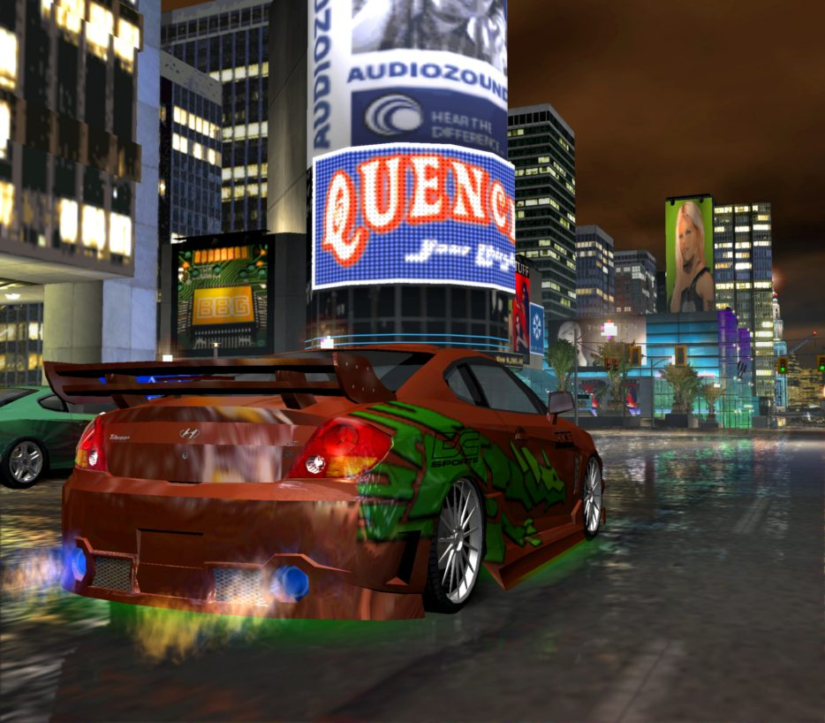

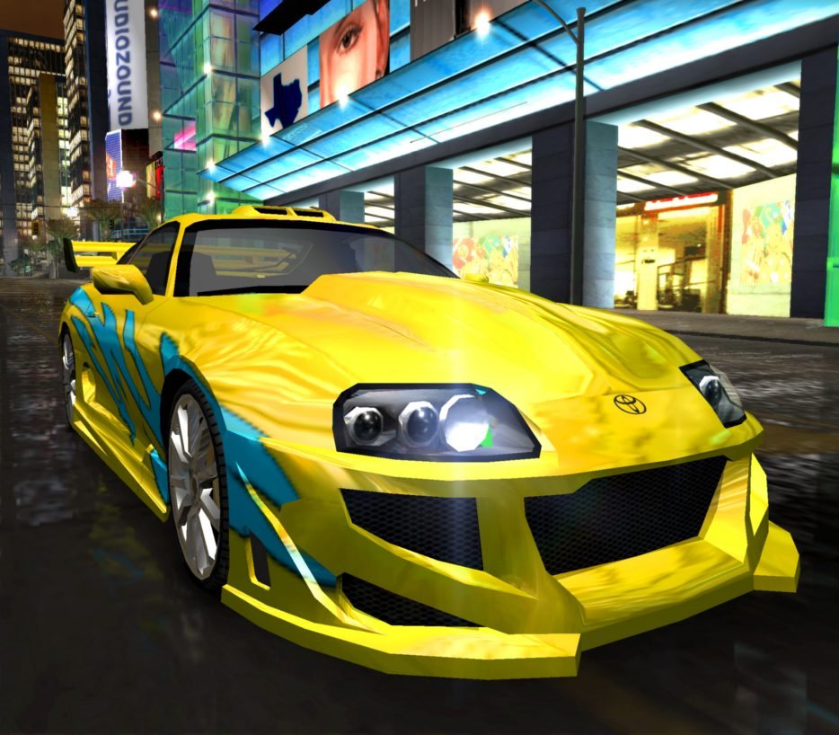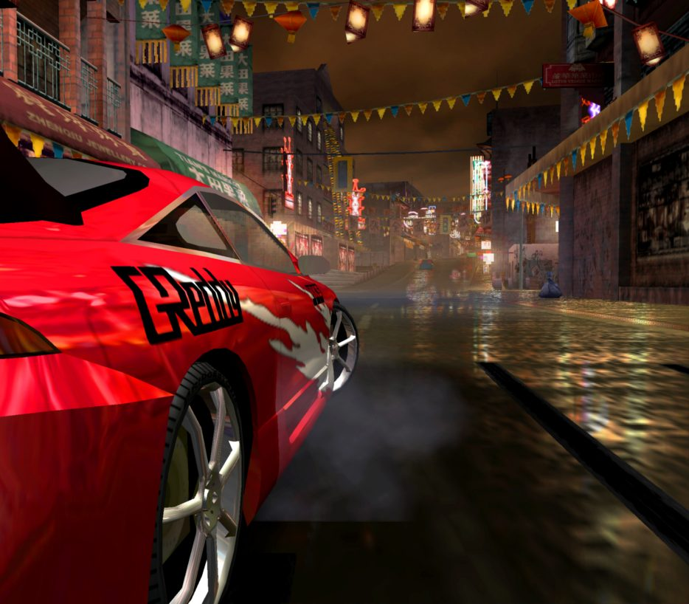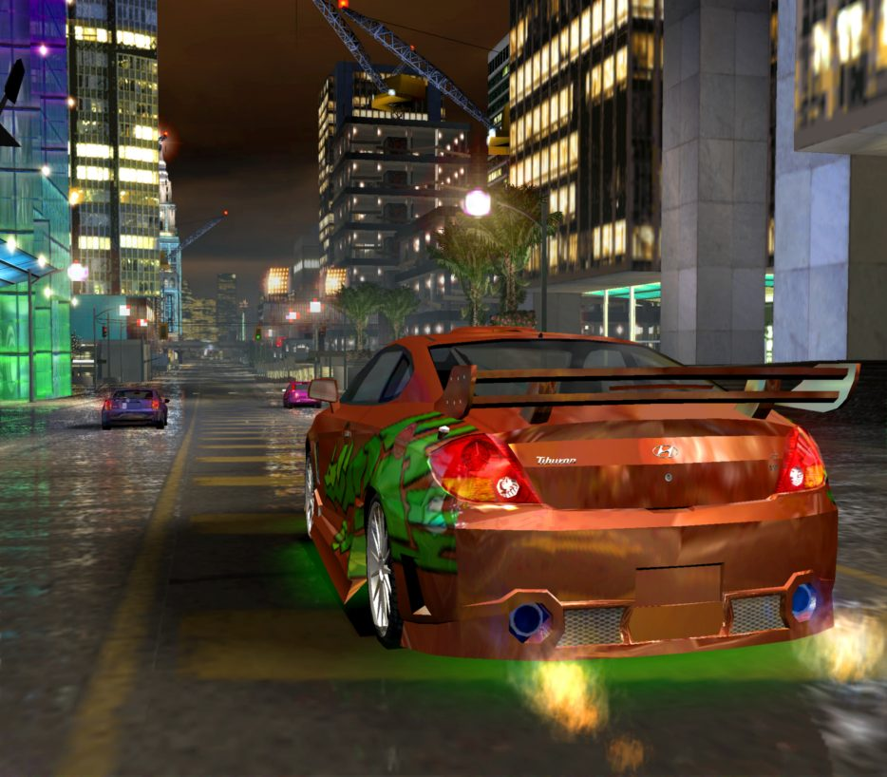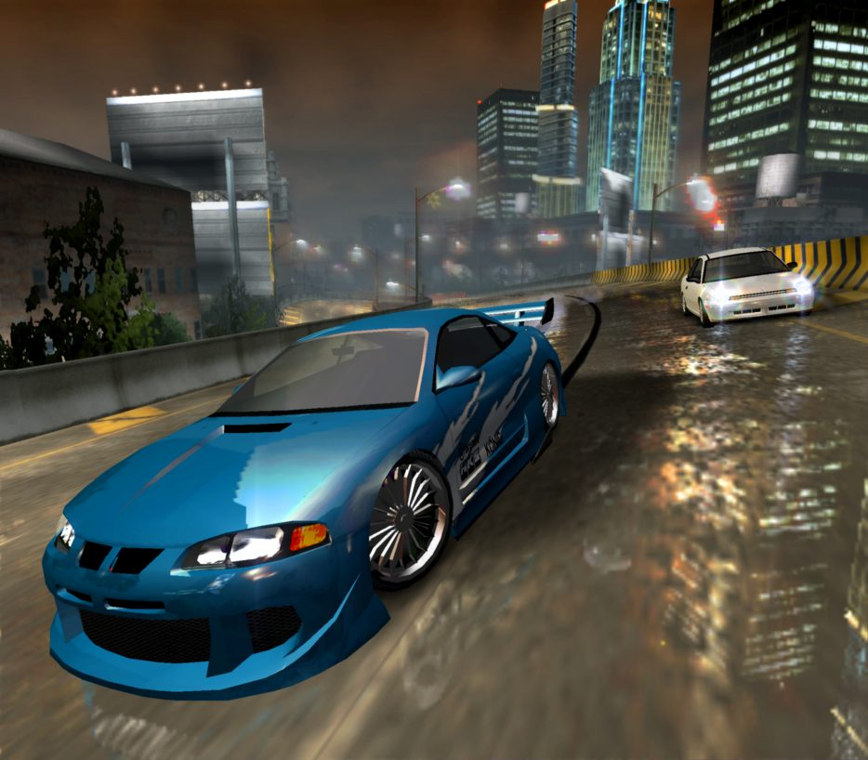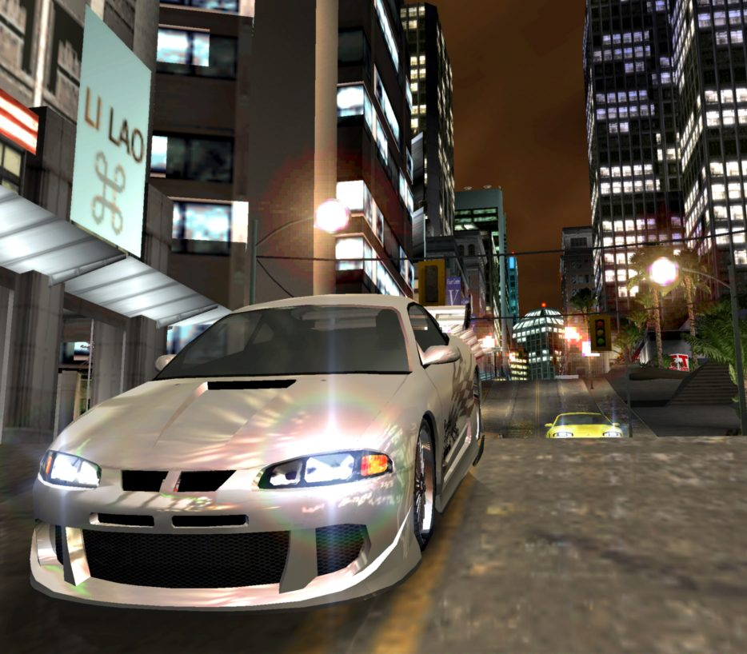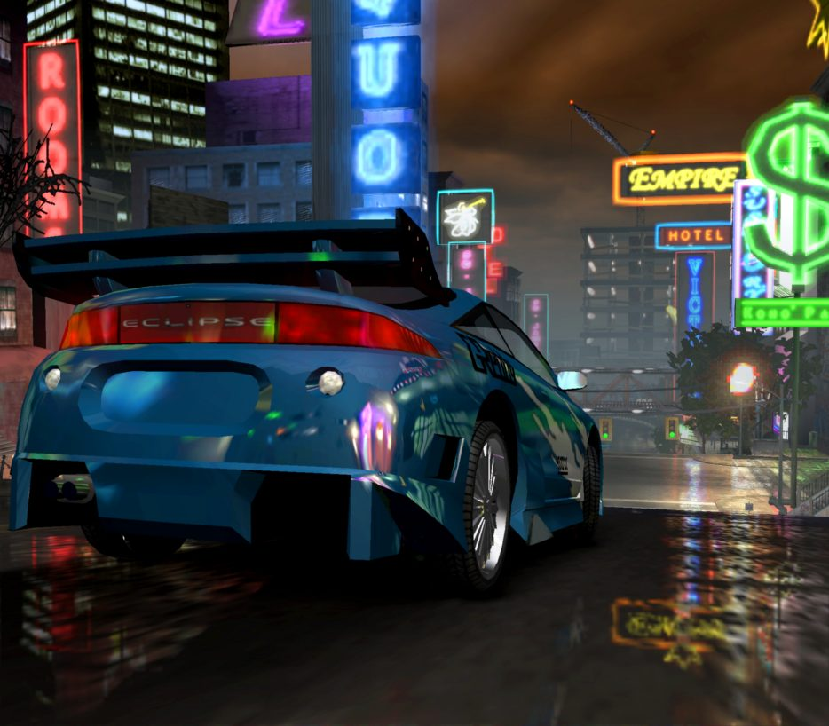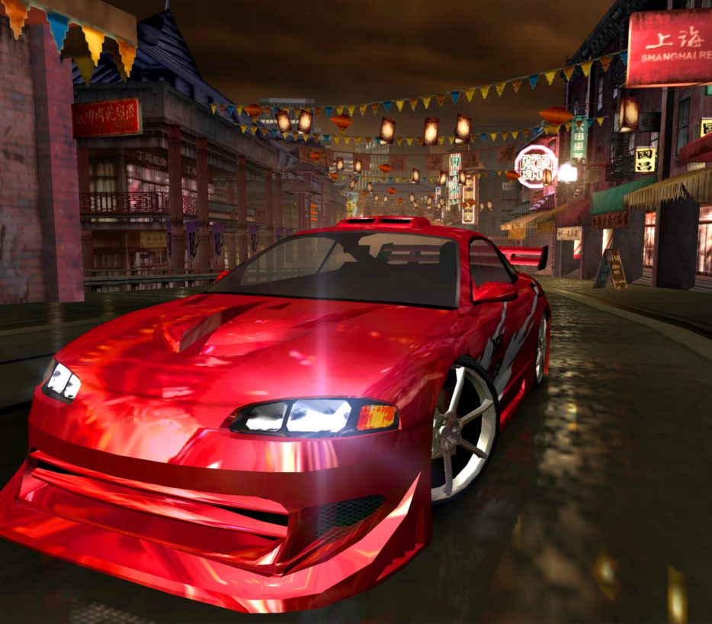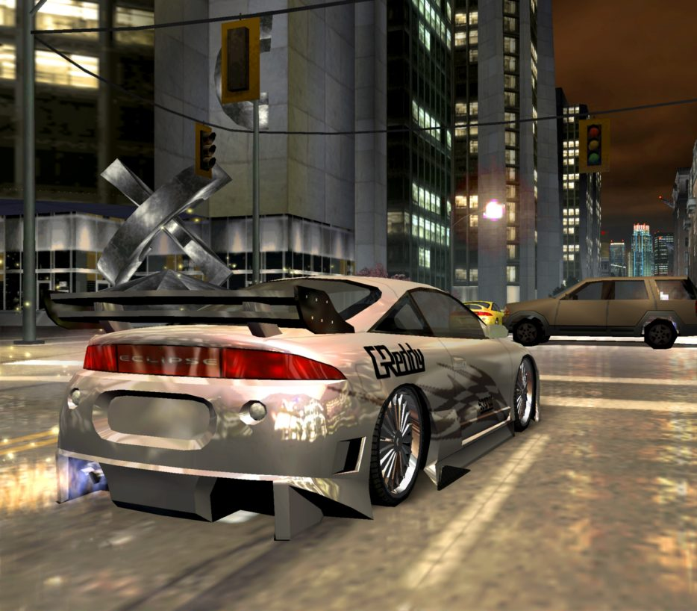

# Schedule & Tasks

|  |  |  |  |  |
| --- | --- | --- | --- | --- |
| **Tasks to Complete & Schedule** | | | | |
| **Tasks** | **Task Lead** | **Start** | **End** | **% Complete** |
| **Development Phase** | | | | |
| Programming |  |  |  |  |
| Main Programming | Arn, [Andy Bakken](https://www.mobygames.com/developer/sheet/view/developerId,72134/), [Ryan Bedard](https://www.mobygames.com/developer/sheet/view/developerId,82156/), [Mike Vlad Cora](https://www.mobygames.com/developer/sheet/view/developerId,114997/), [Spencer Craske](https://www.mobygames.com/developer/sheet/view/developerId,98895/), [Daniel Chitan](https://www.mobygames.com/developer/sheet/view/developerId,98894/), [Euan Forrester](https://www.mobygames.com/developer/sheet/view/developerId,82150/), [James Grieve](https://www.mobygames.com/developer/sheet/view/developerId,47103/), [Robinson Huff](https://www.mobygames.com/developer/sheet/view/developerId,82192/), [Philip Ibis](https://www.mobygames.com/developer/sheet/view/developerId,82152/), [Jeff Johnston](https://www.mobygames.com/developer/sheet/view/developerId,36915/), [Cliff Kondratiuk](https://www.mobygames.com/developer/sheet/view/developerId,98905/), [David Lam](https://www.mobygames.com/developer/sheet/view/developerId,912629/), [David Merriman](https://www.mobygames.com/developer/sheet/view/developerId,115005/), [John Newton](https://www.mobygames.com/developer/sheet/view/developerId,115000/), [Scott Patterson](https://www.mobygames.com/developer/sheet/view/developerId,497637/), [Chris Robertson](https://www.mobygames.com/developer/sheet/view/developerId,82155/), [Wes Santee](https://www.mobygames.com/developer/sheet/view/developerId,77155/), [Martin Sikes](https://www.mobygames.com/developer/sheet/view/developerId,32030/), [Stewart Sockett](https://www.mobygames.com/developer/sheet/view/developerId,113091/), [Lawrence Sparling](https://www.mobygames.com/developer/sheet/view/developerId,82200/), [Tom Spencer-Smith](https://www.mobygames.com/developer/sheet/view/developerId,18373/), [Steve Tolin](https://www.mobygames.com/developer/sheet/view/developerId,115001/), [John Twigg](https://www.mobygames.com/developer/sheet/view/developerId,115002/), [Greg Vance](https://www.mobygames.com/developer/sheet/view/developerId,115003/), [Jason Verhiel](https://www.mobygames.com/developer/sheet/view/developerId,115004/) | 9/4/01 | 28/11/03 | 100 % |
| Additional Programming | [Kosta Arvanitis](https://www.mobygames.com/developer/sheet/view/developerId,115006/), [Allan Antonio](https://www.mobygames.com/developer/sheet/view/developerId,115007/), [Duane Bieber](https://www.mobygames.com/developer/sheet/view/developerId,115008/), [Gregory D'Esposito](https://www.mobygames.com/developer/sheet/view/developerId,23014/), [Bryce Holliday](https://www.mobygames.com/developer/sheet/view/developerId,48684/), [David Ma](https://www.mobygames.com/developer/sheet/view/developerId,115009/), [Bicty Pham](https://www.mobygames.com/developer/sheet/view/developerId,115010/), [Marty Rampton](https://www.mobygames.com/developer/sheet/view/developerId,105937/), [Jonathan Tobias Spangler](https://www.mobygames.com/developer/sheet/view/developerId,82187/), [Eric Tong](https://www.mobygames.com/developer/sheet/view/developerId,115011/), [Angelberto Valenciano Jr.](https://www.mobygames.com/developer/sheet/view/developerId,115012/), [Da Hu Wang](https://www.mobygames.com/developer/sheet/view/developerId,115013/), [Raymond Wang](https://www.mobygames.com/developer/sheet/view/developerId,115014/), [Phillip Weeks](https://www.mobygames.com/developer/sheet/view/developerId,115015/) | 9/4/01 | 28/11/03 | 100 % |
| Art |  |  |  |  |
| Sr. Art Director | [Habib Zargarpour](https://www.mobygames.com/developer/sheet/view/developerId,115016/) | 9/4/01 | 28/11/03 | 100 % |
| Art Director | [Rick Stringfellow](https://www.mobygames.com/developer/sheet/view/developerId,48662/) | 9/4/01 | 28/11/03 | 100 % |
| Technical Art Director | [Russell Rice](https://www.mobygames.com/developer/sheet/view/developerId,27208/) | 9/4/01 | 28/11/03 | 100 % |
| Art Team | |  |  | | --- | --- | |  | [Stéphane Alberola](https://www.mobygames.com/developer/sheet/view/developerId,82158/), [Neil Ambler](https://www.mobygames.com/developer/sheet/view/developerId,55970/), [Jonothan Bate](https://www.mobygames.com/developer/sheet/view/developerId,115017/), [Andy Blackmore](https://www.mobygames.com/developer/sheet/view/developerId,115018/), [Nicholas Burke](https://www.mobygames.com/developer/sheet/view/developerId,82191/), [David Carman](https://www.mobygames.com/developer/sheet/view/developerId,27484/), [Ryan Blanchard](https://www.mobygames.com/developer/sheet/view/developerId,27220/), [Lee Carus-Wescott](https://www.mobygames.com/developer/sheet/view/developerId,3632/), [David Chambers](https://www.mobygames.com/developer/sheet/view/developerId,115019/), [Terry Chui](https://www.mobygames.com/developer/sheet/view/developerId,7647/), [Brendan Cohoe](https://www.mobygames.com/developer/sheet/view/developerId,82146/), [Jo Daly](https://www.mobygames.com/developer/sheet/view/developerId,46027/), [Chris Denschikof](https://www.mobygames.com/developer/sheet/view/developerId,34279/), [Adam Dickinson](https://www.mobygames.com/developer/sheet/view/developerId,122756/), [Gabriel Frizzera](https://www.mobygames.com/developer/sheet/view/developerId,115021/), [Takashi Fukuda](https://www.mobygames.com/developer/sheet/view/developerId,115022/), [Harlan J. Galer](https://www.mobygames.com/developer/sheet/view/developerId,115023/), [Darren W. Gough](https://www.mobygames.com/developer/sheet/view/developerId,82159/), [Michael Hayes](https://www.mobygames.com/developer/sheet/view/developerId,109059/), [Steven Hird](https://www.mobygames.com/developer/sheet/view/developerId,115024/), [Wesley Holder](https://www.mobygames.com/developer/sheet/view/developerId,82160/), [Victor Kam](https://www.mobygames.com/developer/sheet/view/developerId,115025/), [Al Kang](https://www.mobygames.com/developer/sheet/view/developerId,115026/), [Laurie Kindiak](https://www.mobygames.com/developer/sheet/view/developerId,25456/), [Brent Kirby](https://www.mobygames.com/developer/sheet/view/developerId,115027/), [Corey Kleim](https://www.mobygames.com/developer/sheet/view/developerId,115028/), [Martin Konopa](https://www.mobygames.com/developer/sheet/view/developerId,45828/), [Arnel Labarda](https://www.mobygames.com/developer/sheet/view/developerId,27197/), [Li Lao](https://www.mobygames.com/developer/sheet/view/developerId,702869/), [Denny Lau](https://www.mobygames.com/developer/sheet/view/developerId,67092/), [Roger Lee](https://www.mobygames.com/developer/sheet/view/developerId,4869/), [Donnie Madsen](https://www.mobygames.com/developer/sheet/view/developerId,115031/), [Andrew Manns](https://www.mobygames.com/developer/sheet/view/developerId,115032/), [Nigel Middleman](https://www.mobygames.com/developer/sheet/view/developerId,115033/), [Ric Miskimmon](https://www.mobygames.com/developer/sheet/view/developerId,98725/), [Yuta Nakamura](https://www.mobygames.com/developer/sheet/view/developerId,115035/), [Stefan Oberg](https://www.mobygames.com/developer/sheet/view/developerId,82180/), [Mike Olson](https://www.mobygames.com/developer/sheet/view/developerId,82165/), [Adrian Page](https://www.mobygames.com/developer/sheet/view/developerId,362558/), [Alden Phipps](https://www.mobygames.com/developer/sheet/view/developerId,115036/), [Rudy Poat](https://www.mobygames.com/developer/sheet/view/developerId,115037/), [Jackie Marie Ritchie](https://www.mobygames.com/developer/sheet/view/developerId,131510/), [Cassidy Scott](https://www.mobygames.com/developer/sheet/view/developerId,27210/), [Larry Stevens](https://www.mobygames.com/developer/sheet/view/developerId,27216/), [Eric Testroete](https://www.mobygames.com/developer/sheet/view/developerId,115038/), Thursty, [Brian Tolin](https://www.mobygames.com/developer/sheet/view/developerId,115039/), [Dan Vargas](https://www.mobygames.com/developer/sheet/view/developerId,101105/), [Marcus Wild](https://www.mobygames.com/developer/sheet/view/developerId,115040/), [Eduard Visser](https://www.mobygames.com/developer/sheet/view/developerId,115041/), [Ian Williams](https://www.mobygames.com/developer/sheet/view/developerId,66836/), [Julian Yip](https://www.mobygames.com/developer/sheet/view/developerId,115043/) | | 9/4/01 | 28/11/03 | 100 % |
| Additional Art | Light Show Media Corporation, [Craig Mullins](https://www.mobygames.com/developer/sheet/view/developerId,13571/), [Steven Stahlberg](https://www.mobygames.com/developer/sheet/view/developerId,88012/), [Aleksandar Zecevic](https://www.mobygames.com/developer/sheet/view/developerId,1124/) | 9/4/01 | 28/11/03 | 100 % |
| Audio |  |  |  |  |
| Audio Director | [Charles Deenen](https://www.mobygames.com/developer/sheet/view/developerId,5435/) | 9/4/01 | 28/11/03 | 100 % |
| Audio Lead | |  |  | | --- | --- | |  | [Michelle Frey](https://www.mobygames.com/developer/sheet/view/developerId,115213/) | | 9/4/01 | 28/11/03 | 100 % |
| Audio Team | |  |  | | --- | --- | |  | [Rashid Hille](https://www.mobygames.com/developer/sheet/view/developerId,82181/), [Matthew Marteinsson](https://www.mobygames.com/developer/sheet/view/developerId,101058/) | | 9/4/01 | 28/11/03 | 100 % |
| Additional Audio | [Tyler Berry](https://www.mobygames.com/developer/sheet/view/developerId,115215/), [Adam Boyd](https://www.mobygames.com/developer/sheet/view/developerId,88332/), [Jesse Allen](https://www.mobygames.com/developer/sheet/view/developerId,102098/), [Francois Lafleur](https://www.mobygames.com/developer/sheet/view/developerId,46502/), [Eric LeBlanc](https://www.mobygames.com/developer/sheet/view/developerId,72248/), [Jennifer Lewis](https://www.mobygames.com/developer/sheet/view/developerId,25463/) | 9/4/01 | 28/11/03 | 100 % |
| Audio | The Audio Group, Danetracks, NovaStar Post, Soundelux, Wilshire Stages | 9/4/01 | 28/11/03 | 100 % |
| Licensed Music | |  |  | | --- | --- | |  | [Beverly Koeckeritz](https://www.mobygames.com/developer/sheet/view/developerId,25468/), [Cybele Pettus](https://www.mobygames.com/developer/sheet/view/developerId,115454/), [Steven Schnur](https://www.mobygames.com/developer/sheet/view/developerId,72195/) | | 9/4/01 | 28/11/03 | 100 % |
| Development |  |  |  |  |
| Sr. Development Directors | [Marcel Laforce](https://www.mobygames.com/developer/sheet/view/developerId,72153/), [Rick Leczynski](https://www.mobygames.com/developer/sheet/view/developerId,48723/) | 9/4/01 | 28/11/03 | 100 % |
| Development Directors | |  |  | | --- | --- | |  | [Edoardo De Martin](https://www.mobygames.com/developer/sheet/view/developerId,115235/), [Steve Martin](https://www.mobygames.com/developer/sheet/view/developerId,333419/), [Steve Pointon](https://www.mobygames.com/developer/sheet/view/developerId,113090/), [Amy Tipler](https://www.mobygames.com/developer/sheet/view/developerId,82204/) | | 9/4/01 | 28/11/03 | 100 % |
| Production Team | |  |  | | --- | --- | |  | [Serena Blackwood](https://www.mobygames.com/developer/sheet/view/developerId,72155/), [William Ho](https://www.mobygames.com/developer/sheet/view/developerId,32017/), [Scott Nielsen](https://www.mobygames.com/developer/sheet/view/developerId,48761/), [Scott Probin](https://www.mobygames.com/developer/sheet/view/developerId,22447/), [Chuck Osieja](https://www.mobygames.com/developer/sheet/view/developerId,7277/), [Hugues Ricour](https://www.mobygames.com/developer/sheet/view/developerId,115237/), [Nilo Rodis](https://www.mobygames.com/developer/sheet/view/developerId,115238/), [Matthew Tomporowski](https://www.mobygames.com/developer/sheet/view/developerId,82188/), [Greg Uhler](https://www.mobygames.com/developer/sheet/view/developerId,6795/), [Stefan Q. Wessels](https://www.mobygames.com/developer/sheet/view/developerId,82182/), [Justin Wiebe](https://www.mobygames.com/developer/sheet/view/developerId,26354/) | | 9/4/01 | 28/11/03 | 100 % |
| Studio VP. Executive Producer | [Hanno Lemke](https://www.mobygames.com/developer/sheet/view/developerId,4389/) | 9/4/01 | 28/11/03 | 100 % |
| VP of Product Development | [Jerry Bowerman](https://www.mobygames.com/developer/sheet/view/developerId,5670/) | 9/4/01 | 28/11/03 | 100 % |
| Production Support | [Cindy Lee](https://www.mobygames.com/developer/sheet/view/developerId,55523/), [Lia Siojo](https://www.mobygames.com/developer/sheet/view/developerId,66619/), [Priscilla Wyrzykowski](https://www.mobygames.com/developer/sheet/view/developerId,82205/), [Alan Goldman](https://www.mobygames.com/developer/sheet/view/developerId,99658/) | 9/4/01 | 28/11/03 | 100 % |
| Localization Coordination | [Philip Arnell](https://www.mobygames.com/developer/sheet/view/developerId,115239/), [Bettina Bachon](https://www.mobygames.com/developer/sheet/view/developerId,15563/), [Claudia Casagrande](https://www.mobygames.com/developer/sheet/view/developerId,115240/), [Sylvain Caburrosso](https://www.mobygames.com/developer/sheet/view/developerId,15206/), [Patrick Coleman](https://www.mobygames.com/developer/sheet/view/developerId,28211/), [Britta Dohmen](https://www.mobygames.com/developer/sheet/view/developerId,104085/), [Adeline Guichard-Lepetit](https://www.mobygames.com/developer/sheet/view/developerId,430606/), [Inés Hernández](https://www.mobygames.com/developer/sheet/view/developerId,115241/), [Antonio Gomes](https://www.mobygames.com/developer/sheet/view/developerId,115242/), [Mia Opancar](https://www.mobygames.com/developer/sheet/view/developerId,29553/), [Zelita Rodrigues](https://www.mobygames.com/developer/sheet/view/developerId,115243/) | 9/4/01 | 28/11/03 | 100 % |
| Localization Support | [Javier Alonso](https://www.mobygames.com/developer/sheet/view/developerId,115288/), [Thomas Baedorff](https://www.mobygames.com/developer/sheet/view/developerId,115289/), [Rémi Berthet](https://www.mobygames.com/developer/sheet/view/developerId,72179/), [Pierre-Henri Bouthier](https://www.mobygames.com/developer/sheet/view/developerId,115290/), [Derek Fitzgerald](https://www.mobygames.com/developer/sheet/view/developerId,115291/), [Jesús Gorriti](https://www.mobygames.com/developer/sheet/view/developerId,115292/), [Marcel Kuhn](https://www.mobygames.com/developer/sheet/view/developerId,50934/), [Mattias Lönnqvist](https://www.mobygames.com/developer/sheet/view/developerId,115293/), [Jorge Manchón](https://www.mobygames.com/developer/sheet/view/developerId,115294/), [Bertrand Mangin](https://www.mobygames.com/developer/sheet/view/developerId,111806/), [Matteo Milandri](https://www.mobygames.com/developer/sheet/view/developerId,101076/), [Takeshi Miyazoe](https://www.mobygames.com/developer/sheet/view/developerId,115295/), [Ulrich Pelikan](https://www.mobygames.com/developer/sheet/view/developerId,115296/), [Andrea Santambrogio](https://www.mobygames.com/developer/sheet/view/developerId,79845/), Binari Sonori, [Marco van der Toorn](https://www.mobygames.com/developer/sheet/view/developerId,115298/), U-TRAX Multi Media Localisations, [Robert Wyle](https://www.mobygames.com/developer/sheet/view/developerId,72168/) | 9/4/01 | 28/11/03 | 100 % |
| External Development Team | Active Cell Development, Game World 7, Matahari, Mind Quake Media, [Daniel Seiberling](https://www.mobygames.com/developer/sheet/view/developerId,82169/), Vicarious Visions, Warthog, Wild Brain | 9/4/01 | 28/11/03 | 100 % |
| Casting | [Chris Borders](https://www.mobygames.com/developer/sheet/view/developerId,5443/), [Marci Galea](https://www.mobygames.com/developer/sheet/view/developerId,167655/), [Barbara Harris](https://www.mobygames.com/developer/sheet/view/developerId,13537/) | 9/4/01 | 28/11/03 | 100 % |
| **Testing Phase** | | | | |
| Sr. Project Manager | [Paula Gil](https://www.mobygames.com/developer/sheet/view/developerId,115316/) | 9/4/01 | 28/11/03 | 100 % |
| Project Manager | [Frank Benton](https://www.mobygames.com/developer/sheet/view/developerId,122150/) | 9/4/01 | 28/11/03 | 100 % |
| Team Leads | |  |  | | --- | --- | |  | [Cindy Currie](https://www.mobygames.com/developer/sheet/view/developerId,67120/), [Peter Farkas](https://www.mobygames.com/developer/sheet/view/developerId,122151/), [Wojtek Mikulik](https://www.mobygames.com/developer/sheet/view/developerId,115317/), [Max Prangnell](https://www.mobygames.com/developer/sheet/view/developerId,115318/) | | 9/4/01 | 28/11/03 | 100 % |
| Testers | |  |  | | --- | --- | |  | [Chris Aduna](https://www.mobygames.com/developer/sheet/view/developerId,115324/), [Anthony Ahamed](https://www.mobygames.com/developer/sheet/view/developerId,72162/), [Roland Au-Yeung](https://www.mobygames.com/developer/sheet/view/developerId,115325/), [Ryan Barr](https://www.mobygames.com/developer/sheet/view/developerId,841453/), [Harkirat Bhangav](https://www.mobygames.com/developer/sheet/view/developerId,115326/), [Olivia Bogacki](https://www.mobygames.com/developer/sheet/view/developerId,50908/), [Kristian Bourdage](https://www.mobygames.com/developer/sheet/view/developerId,115327/), [Richard Bouvier](https://www.mobygames.com/developer/sheet/view/developerId,115328/), [Shaun Bullied](https://www.mobygames.com/developer/sheet/view/developerId,115329/), [Kent Cheng](https://www.mobygames.com/developer/sheet/view/developerId,115330/), [Eric Cheung](https://www.mobygames.com/developer/sheet/view/developerId,115331/), [Edward Chin](https://www.mobygames.com/developer/sheet/view/developerId,47314/), [Edmund Chow](https://www.mobygames.com/developer/sheet/view/developerId,115332/), [Steven Donaghy](https://www.mobygames.com/developer/sheet/view/developerId,115333/), [Martin Folprecht](https://www.mobygames.com/developer/sheet/view/developerId,115334/), [Stephen Handelsman](https://www.mobygames.com/developer/sheet/view/developerId,115335/), [Kelvin Hoyle](https://www.mobygames.com/developer/sheet/view/developerId,115336/), [Andersen Kang](https://www.mobygames.com/developer/sheet/view/developerId,115337/), [Otto Kauffmann](https://www.mobygames.com/developer/sheet/view/developerId,115353/), [Evan Kennedy](https://www.mobygames.com/developer/sheet/view/developerId,108578/), [Terry Kineshanko](https://www.mobygames.com/developer/sheet/view/developerId,67498/), [David Klann](https://www.mobygames.com/developer/sheet/view/developerId,67499/), [Richard Kocurek](https://www.mobygames.com/developer/sheet/view/developerId,108573/), [Andre Lam](https://www.mobygames.com/developer/sheet/view/developerId,115338/), [David Lawrence](https://www.mobygames.com/developer/sheet/view/developerId,395147/), [Arnaud Lebesnerais](https://www.mobygames.com/developer/sheet/view/developerId,115339/), [Johnny Lee](https://www.mobygames.com/developer/sheet/view/developerId,115340/), [Nelson Lee](https://www.mobygames.com/developer/sheet/view/developerId,23403/), [Hurbert Leung](https://www.mobygames.com/developer/sheet/view/developerId,115341/), [Wade Lindley](https://www.mobygames.com/developer/sheet/view/developerId,27426/), [Darren Louie](https://www.mobygames.com/developer/sheet/view/developerId,115342/), [Bron Mach](https://www.mobygames.com/developer/sheet/view/developerId,113475/), [Morgan Madu](https://www.mobygames.com/developer/sheet/view/developerId,115343/), [Edmond Mai](https://www.mobygames.com/developer/sheet/view/developerId,108581/), [Robert McInnis](https://www.mobygames.com/developer/sheet/view/developerId,77471/), [Cam McRae](https://www.mobygames.com/developer/sheet/view/developerId,115344/), [Shyam Nathwani](https://www.mobygames.com/developer/sheet/view/developerId,115345/), [Sherborne Pao](https://www.mobygames.com/developer/sheet/view/developerId,115346/), [Darren Roberts](https://www.mobygames.com/developer/sheet/view/developerId,67503/), [Matthew Robertson](https://www.mobygames.com/developer/sheet/view/developerId,45568/), [Jasbir Singh Roopra](https://www.mobygames.com/developer/sheet/view/developerId,115347/), [Jason Schuss](https://www.mobygames.com/developer/sheet/view/developerId,67505/), [Matt Smits](https://www.mobygames.com/developer/sheet/view/developerId,115348/), [Jody Torrance](https://www.mobygames.com/developer/sheet/view/developerId,115349/), [Peter Waldkirch](https://www.mobygames.com/developer/sheet/view/developerId,115350/), [Jeff Wilson](https://www.mobygames.com/developer/sheet/view/developerId,3793/), [Lorne Wilson](https://www.mobygames.com/developer/sheet/view/developerId,47345/), [Don Wong](https://www.mobygames.com/developer/sheet/view/developerId,115351/), [Jason Wong](https://www.mobygames.com/developer/sheet/view/developerId,330601/), [Kenneth Young](https://www.mobygames.com/developer/sheet/view/developerId,244915/) | | 9/4/01 | 28/11/03 | 100 % |
| **Motion Capture** |  |  |  |  |
| Motion Capture Lead | [Wilson Leung](https://www.mobygames.com/developer/sheet/view/developerId,66620/) | 9/4/01 | 28/11/03 | 100 % |
| Additional Motion Capture | [Stefan Van Niekerk](https://www.mobygames.com/developer/sheet/view/developerId,48784/), [Ben Guthrie](https://www.mobygames.com/developer/sheet/view/developerId,96213/), [Evan Tepoorten](https://www.mobygames.com/developer/sheet/view/developerId,115360/), [Ryan Hietanen](https://www.mobygames.com/developer/sheet/view/developerId,160095/) | 9/4/01 | 28/11/03 | 100 % |
| Motion Capture Talent | [Alex Pesusich](https://www.mobygames.com/developer/sheet/view/developerId,115400/), [Carla Catherwood](https://www.mobygames.com/developer/sheet/view/developerId,115401/), [David Hobbins](https://www.mobygames.com/developer/sheet/view/developerId,115402/), [Donovan Stinson](https://www.mobygames.com/developer/sheet/view/developerId,101106/), [Eric Perrier](https://www.mobygames.com/developer/sheet/view/developerId,48774/), [Jennifer Copping](https://www.mobygames.com/developer/sheet/view/developerId,115403/), [Joel Pennington](https://www.mobygames.com/developer/sheet/view/developerId,101104/), [Ken Tsia](https://www.mobygames.com/developer/sheet/view/developerId,48786/), [Koenraad Beugelink](https://www.mobygames.com/developer/sheet/view/developerId,115405/), [Lynn Corcuera](https://www.mobygames.com/developer/sheet/view/developerId,111857/), [Stuart Pierre](https://www.mobygames.com/developer/sheet/view/developerId,115406/) | 9/4/01 | 28/11/03 | 100 % |
| **Marketing and PR** |  |  |  |  |
| Director of Marketing | [Keith Munro](https://www.mobygames.com/developer/sheet/view/developerId,41133/) | 9/4/01 | 28/11/03 | 100 % |
| Product Manager | [Christopher Lee](https://www.mobygames.com/developer/sheet/view/developerId,148897/) | 9/4/01 | 28/11/03 | 100 % |
| Marketing Team | [Racquel Mateo](https://www.mobygames.com/developer/sheet/view/developerId,115408/) | 9/4/01 | 28/11/03 | 100 % |
| Public Relations | [Bryce Baer](https://www.mobygames.com/developer/sheet/view/developerId,66454/), EARS PR team | 9/4/01 | 28/11/03 | 100 % |
| Licensing | [Paul Cairns](https://www.mobygames.com/developer/sheet/view/developerId,42676/), [Sigrun Handle](https://www.mobygames.com/developer/sheet/view/developerId,115409/), [Masaaki Kawamura](https://www.mobygames.com/developer/sheet/view/developerId,50428/), [Patrick J. O'Brien](https://www.mobygames.com/developer/sheet/view/developerId,67116/), [Jennifer Tait](https://www.mobygames.com/developer/sheet/view/developerId,72193/) | 9/4/01 | 28/11/03 | 100 % |
| Ad Sales | |  |  | | --- | --- | |  | [Noreen Dante](https://www.mobygames.com/developer/sheet/view/developerId,30324/), [Jay Miller](https://www.mobygames.com/developer/sheet/view/developerId,558010/), [Jim Stadelman](https://www.mobygames.com/developer/sheet/view/developerId,111827/) | | 9/4/01 | 28/11/03 | 100 % |
| Special Thanks | [Marc Aubanel](https://www.mobygames.com/developer/sheet/view/developerId,7638/), [Glenn Chin](https://www.mobygames.com/developer/sheet/view/developerId,7380/), [Marc DeVellis](https://www.mobygames.com/developer/sheet/view/developerId,115410/), [Tiffany Edwardsen](https://www.mobygames.com/developer/sheet/view/developerId,115411/), Garage Five Performance, [Christophe Juncker](https://www.mobygames.com/developer/sheet/view/developerId,72211/) (Logitech), [John Schappert](https://www.mobygames.com/developer/sheet/view/developerId,66180/), [Masami Takahashi](https://www.mobygames.com/developer/sheet/view/developerId,50945/), [Christopher Thompson](https://www.mobygames.com/developer/sheet/view/developerId,650522/), [Tae Woon Yoon](https://www.mobygames.com/developer/sheet/view/developerId,72184/) | 9/4/01 | 28/11/03 | 100 % |
| Models | |  |  | | --- | --- | |  | [Cindy Johnson](https://www.mobygames.com/developer/sheet/view/developerId,984842/), [Amy Walz](https://www.mobygames.com/developer/sheet/view/developerId,115413/) | | 9/4/01 | 28/11/03 | 100 % |
| Additional Models | [Sarah Buan](https://www.mobygames.com/developer/sheet/view/developerId,115414/), [Mariko Iwaya](https://www.mobygames.com/developer/sheet/view/developerId,115415/), [Barbara Lo](https://www.mobygames.com/developer/sheet/view/developerId,115416/), [April Kwan](https://www.mobygames.com/developer/sheet/view/developerId,115417/), [Ashley Mandryk](https://www.mobygames.com/developer/sheet/view/developerId,115418/), [Jessykah Ng](https://www.mobygames.com/developer/sheet/view/developerId,115419/), [Dafne Sagastume](https://www.mobygames.com/developer/sheet/view/developerId,115420/), [Sara Steer](https://www.mobygames.com/developer/sheet/view/developerId,115421/), [Sara Thiessen](https://www.mobygames.com/developer/sheet/view/developerId,115422/), [Julie Trieu](https://www.mobygames.com/developer/sheet/view/developerId,115423/), [Fionna Tse](https://www.mobygames.com/developer/sheet/view/developerId,115424/) | 9/4/01 | 28/11/03 | 100 % |
| Photographer | [Boaz Joseph](https://www.mobygames.com/developer/sheet/view/developerId,115425/) | 9/4/01 | 28/11/03 | 100 % |
| Voice Talent | |  |  | | --- | --- | |  | [Ignacio Aldeguer](https://www.mobygames.com/developer/sheet/view/developerId,115426/), [Sharon Alexander](https://www.mobygames.com/developer/sheet/view/developerId,72203/), [David Barrera](https://www.mobygames.com/developer/sheet/view/developerId,115427/), [Michael Benyaer](https://www.mobygames.com/developer/sheet/view/developerId,20141/), [Chopper Bernet](https://www.mobygames.com/developer/sheet/view/developerId,4749/), [Alain Blasquez](https://www.mobygames.com/developer/sheet/view/developerId,115429/), [Rasmus Borowski](https://www.mobygames.com/developer/sheet/view/developerId,115430/), [Valérie Boyer](https://www.mobygames.com/developer/sheet/view/developerId,115431/), [Thierry Buenafuente](https://www.mobygames.com/developer/sheet/view/developerId,115432/), [Danny Cooksey](https://www.mobygames.com/developer/sheet/view/developerId,115433/), [Joey Cordevin](https://www.mobygames.com/developer/sheet/view/developerId,115434/), [Roberto Cuenca Martínez](https://www.mobygames.com/developer/sheet/view/developerId,115435/), [Sascha Draeger](https://www.mobygames.com/developer/sheet/view/developerId,6863/), [Marek Erhardt](https://www.mobygames.com/developer/sheet/view/developerId,124999/), [Ricardo Escobar](https://www.mobygames.com/developer/sheet/view/developerId,115199/), [Nicolás Figueras](https://www.mobygames.com/developer/sheet/view/developerId,115437/), [Michael Grimm](https://www.mobygames.com/developer/sheet/view/developerId,43058/), [Iván Jara](https://www.mobygames.com/developer/sheet/view/developerId,115438/), [Adam Lawson](https://www.mobygames.com/developer/sheet/view/developerId,115439/), [Damien Laquet](https://www.mobygames.com/developer/sheet/view/developerId,115440/), [Martin May](https://www.mobygames.com/developer/sheet/view/developerId,29468/), [Pilar Martín](https://www.mobygames.com/developer/sheet/view/developerId,115441/), [Alejandro Martínez](https://www.mobygames.com/developer/sheet/view/developerId,115442/), [José Antonio Moratalla](https://www.mobygames.com/developer/sheet/view/developerId,115443/), [Ángel Morón](https://www.mobygames.com/developer/sheet/view/developerId,159466/), [Laurent Pasquier](https://www.mobygames.com/developer/sheet/view/developerId,34053/), [Mike Powers](https://www.mobygames.com/developer/sheet/view/developerId,115445/), [Jan-David Rönfeld](https://www.mobygames.com/developer/sheet/view/developerId,115446/), [Jorge Saudinós](https://www.mobygames.com/developer/sheet/view/developerId,115447/), [Tobias Schmidt](https://www.mobygames.com/developer/sheet/view/developerId,115448/), [Charo Soria](https://www.mobygames.com/developer/sheet/view/developerId,115449/), [Donovan Stinson](https://www.mobygames.com/developer/sheet/view/developerId,101106/), [Jens Wendland](https://www.mobygames.com/developer/sheet/view/developerId,115451/), [Sean Whale](https://www.mobygames.com/developer/sheet/view/developerId,115452/), [Cory White](https://www.mobygames.com/developer/sheet/view/developerId,115453/) | | 9/4/01 | 28/11/03 | 100 % |